Kickstarter Campaigns

## By: Rose Militante

1. Given the provided data, what are three conclusions we can draw about Kickstarter campaigns?

* There’s an abundance of kickstarter campaigns in the theater and music categories which in turn have proven to be most successful.

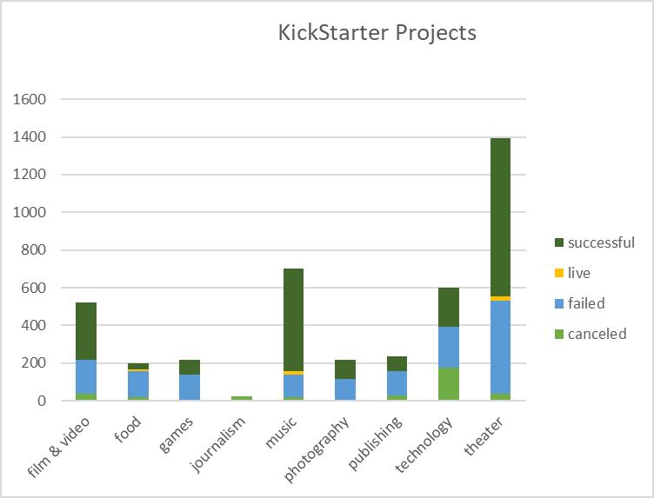

* Kickstarters in the web category have either failed or been canceled.

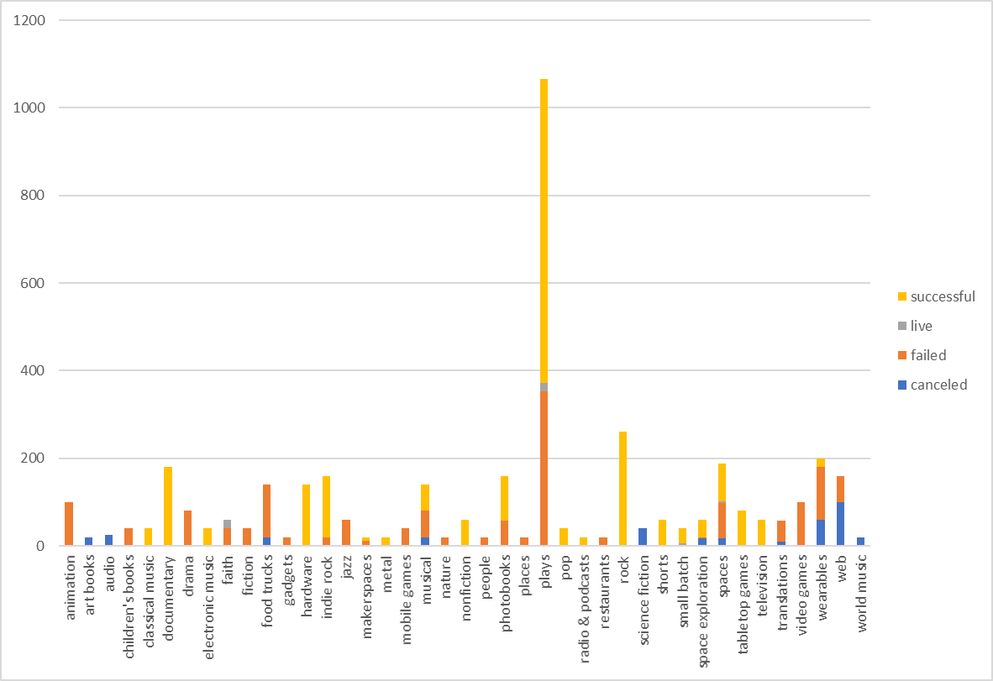

* Campaigns that begin in the 1st quarter of a calendar year have the highest success rates.

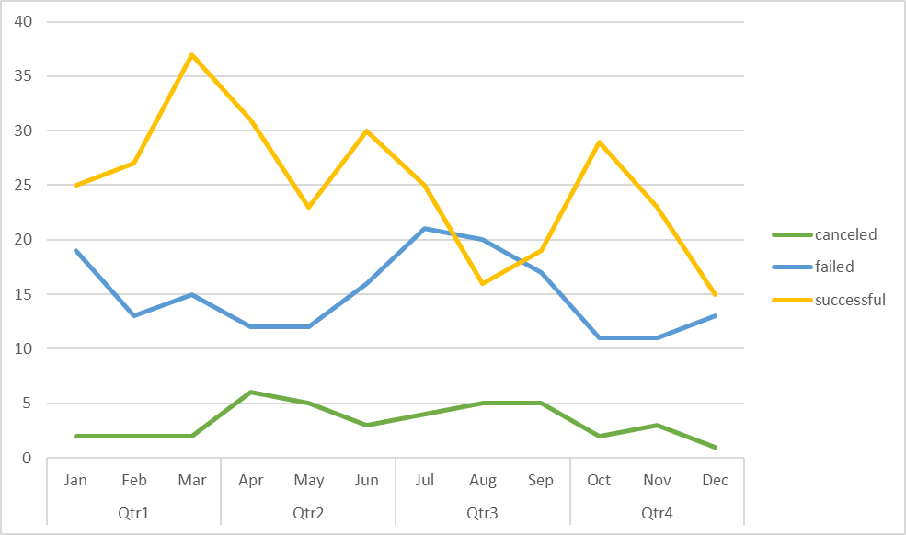

1. What are some limitations of this dataset?

* The backers’ profile (age, sex, nationality) is not identified in the dataset.
* The criteria to determine a campaign’s state (failed / successful) isn’t clear.
* How frequent do the backers fund kickstarters? Are they one-time investors?

1. What are some other possible tables and/or graphs that we could create?

* Chart the average backers spend in correlation to a campaign’s success.
* What countries have the most successful/unsuccessful campaigns?
* How does a campaign’s elapsed length of time from launch to deadline impact its success?